**CS 3354 Software Engineering**

**Final Project Deliverable 2**

**SmartShopper**

Andres Uriegas, Anthony Tomsio, Giakhanh Hoang, Kevin Chen, Palak Sharma, Tien Quang

1. **Delegation of tasks:**
   1. Andres Uriegas - Conclusion, references
   2. Anthony Tomsio - Cost, effort, pricing estimation, slides
   3. Giakhanh Hoang - JUnit testing
   4. Kevin Chen - Project scheduling and UI Design
   5. Palak Sharma - Comparison, slides
   6. Tien Quang - Cost estimations, slides
2. **Project Deliverable 1 Content:**

**A. Draft Project Description**

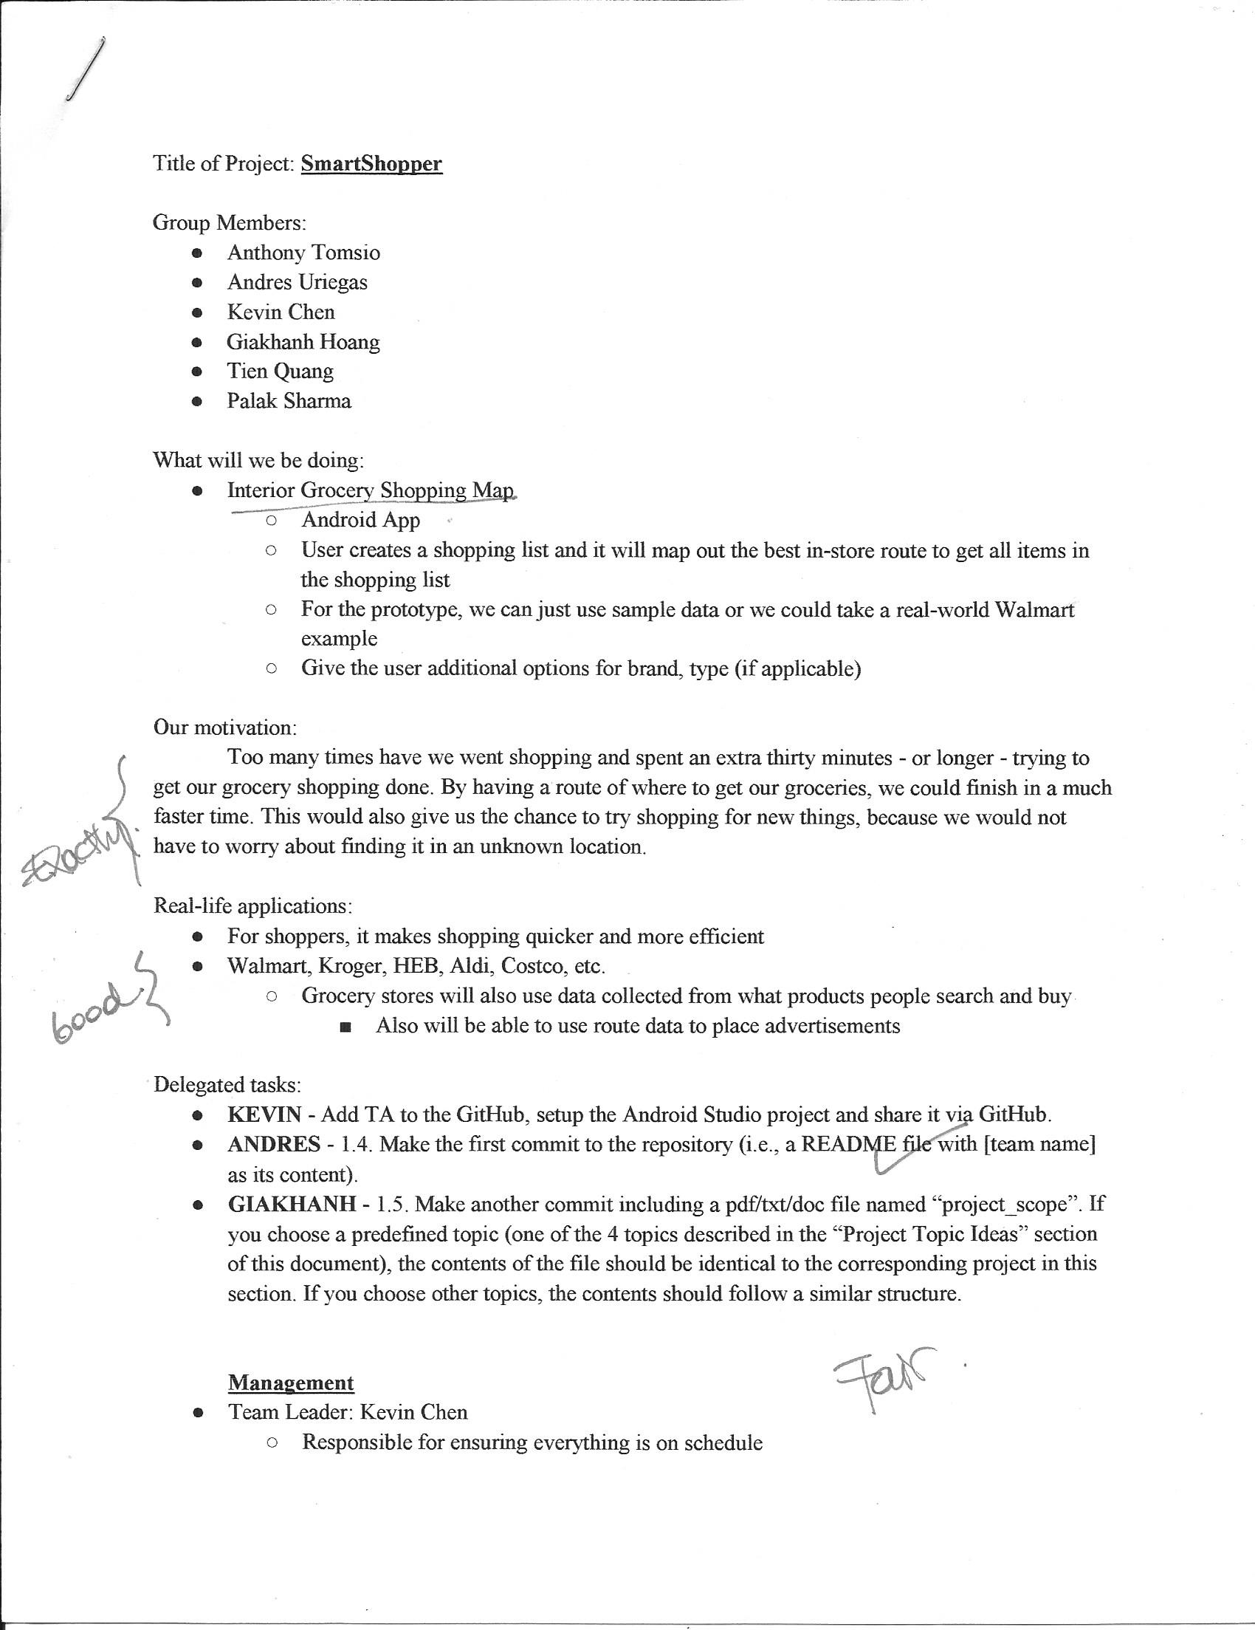

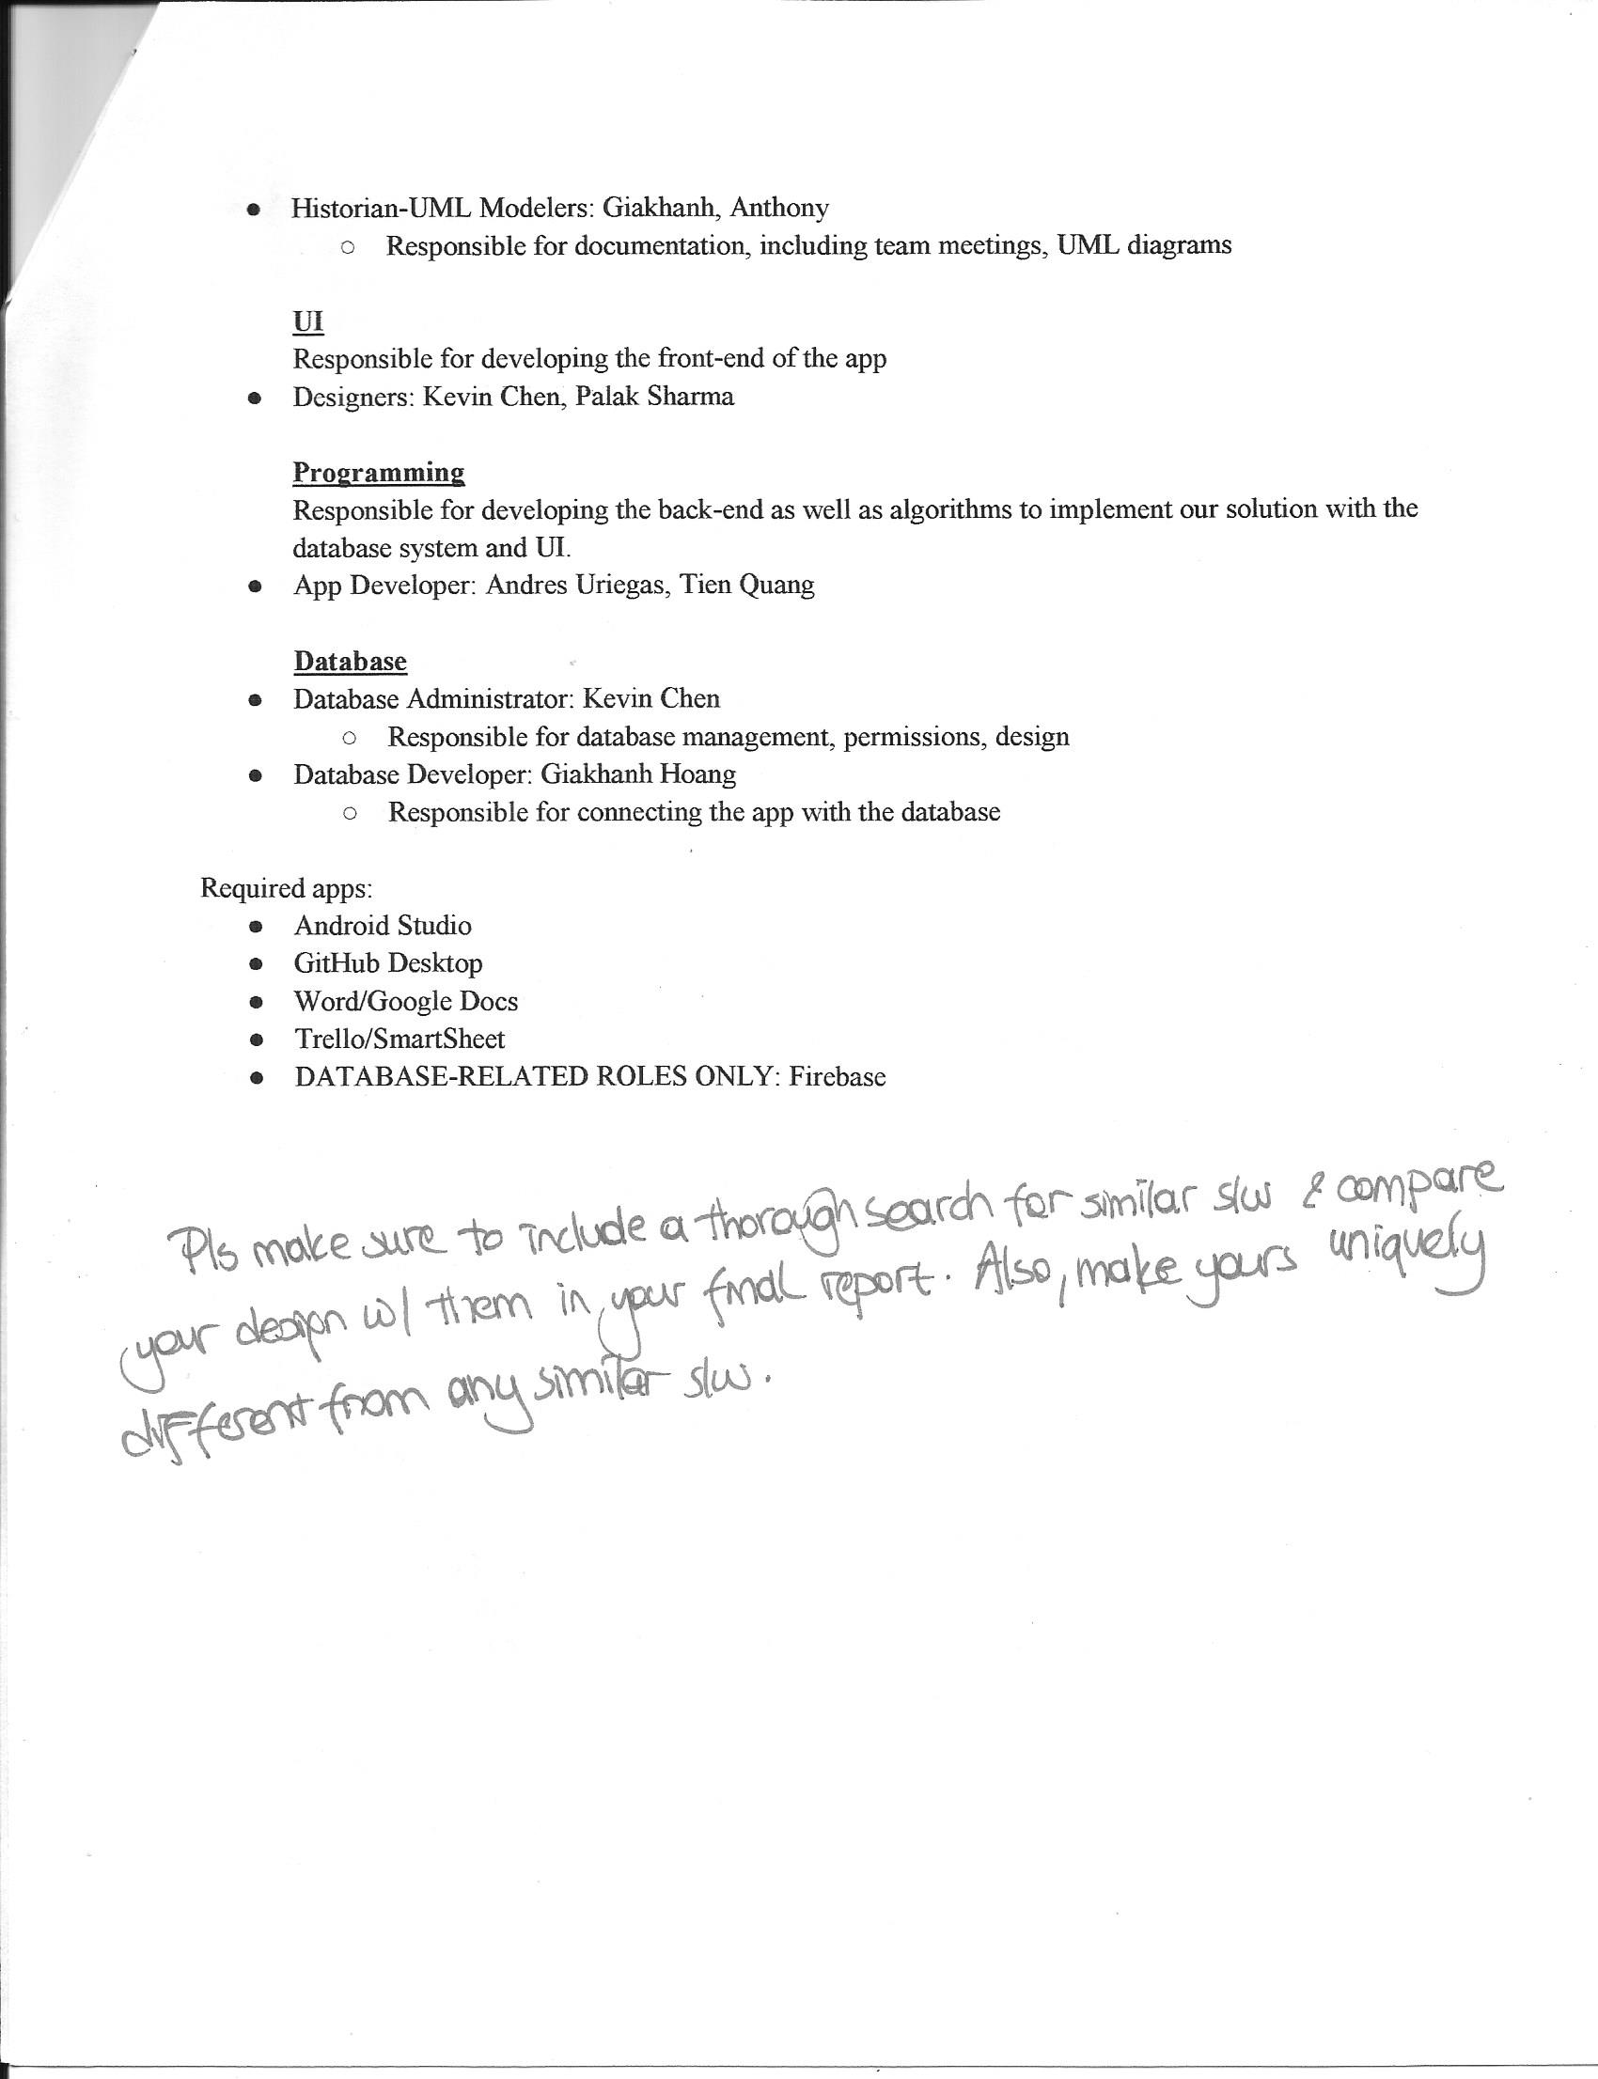

Response to the feedback: We used crowdsourcing to differentiate our product from other products on the market. With crowdsourcing, when data about a product’s attributes, such as location, type, etc. changes, customers will be able to go into the app to change the product’s attributes.

**URL** of our team project repository: <https://github.com/nich227/3354-smartshopper>

**B. Delegation of tasks**

**Management:** Kevin Chen

* Responsible for ensuring everything is on schedule

**Historian-UML Modelers**: Giakhanh Hoang, Anthony Tomsio

* Responsible for documentation, including team meetings, UML diagrams

**UI Designers:** Kevin Chen, Palak Sharma

* Responsible for developing the front-end of the app

**App Developers:** Andres Uriegas, Tien Quang

* Responsible for developing the back-end as well as algorithms to implement our solution with the database system and UI.

**Database Administrator:** Kevin Chen

* Responsible for database management, permissions, design

**Database Developer:** Giakhanh Hoang

* Responsible for connecting the app with the database

**C. Software Process Model employed**

The software process model that we’re utilizing for our project is Scrum. It is an agile based software methodology which utilizes an online tool called Trello to keep track of To-do and Done tasks. Agile software development, specifically Scrum, helps the team to keep track of features that need to be implemented into the final product and allows for faster development. Every week, we conduct a meeting to work on certain documentation, figure out what we need to be working on, and then before we adjourn the meeting we record the tasks that need to be completed by the next meeting. This is completed through a sprint process. Agile also allows for faster releases; so, if there is a known issue during a release, it can be fixed on the next release.

**D. Software Requirements**

**a) Functional Requirements**

* Get grocery list from user, look through products in the store through a database
* Find best-fit-route based off of an algorithm such as Kruskal’s
* Authenticate user logins using the database
* Display store map to the user
* Data for each of the products can be modified by the users

**b) Non-functional Requirements**

Product requirements

* Usability requirements
  + User-Friendly
* Efficiency requirements
  + Performance requirements
    - Retrieves data from the database with as little overhead as possible (at worst 3 seconds)
    - Phone app does not bog down the phone’s RAM (<512 MB ideally)
  + Space requirements
    - Minimize phone storage by using database storage of most data
* Dependability requirements
  + Offline mode for spotty store connection
* Security requirements
  + Don’t let unauthorized users access database
  + Encrypt private user information

Organizational requirements

* Environmental requirements
  + App, interpretation of data on a smartphone
  + Database in a Google Cloud server
* Operational requirements
  + Compatible with all smartphones running Android 5.0-9.0
* Developmental requirements
  + Android Studio on Windows, Mac
  + Pair programming for collaboration

External requirements

* Regulatory requirements
  + Ensure that user’s privacy is respected
  + Don’t share internal data for companies with the world
* Ethical requirements
  + Must not use user’s data without authorization
* Legislative requirements
  + Accounting requirements
    - Report general app statistics and usage data
  + Safety/Security requirements
    - Confidential integrity for each user’s personal data

**E. Use case diagram**

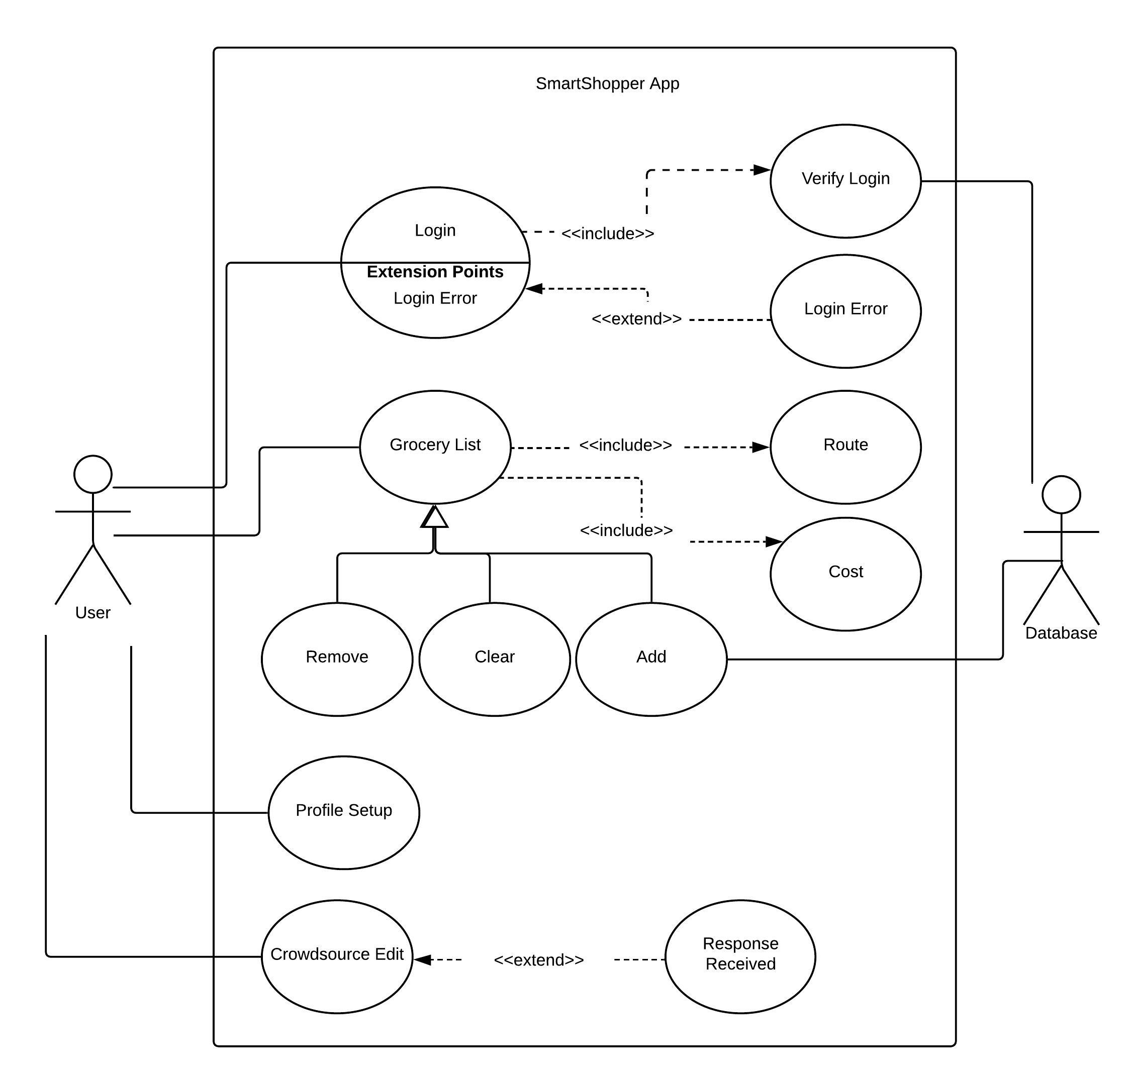

**F. Sequence diagram**

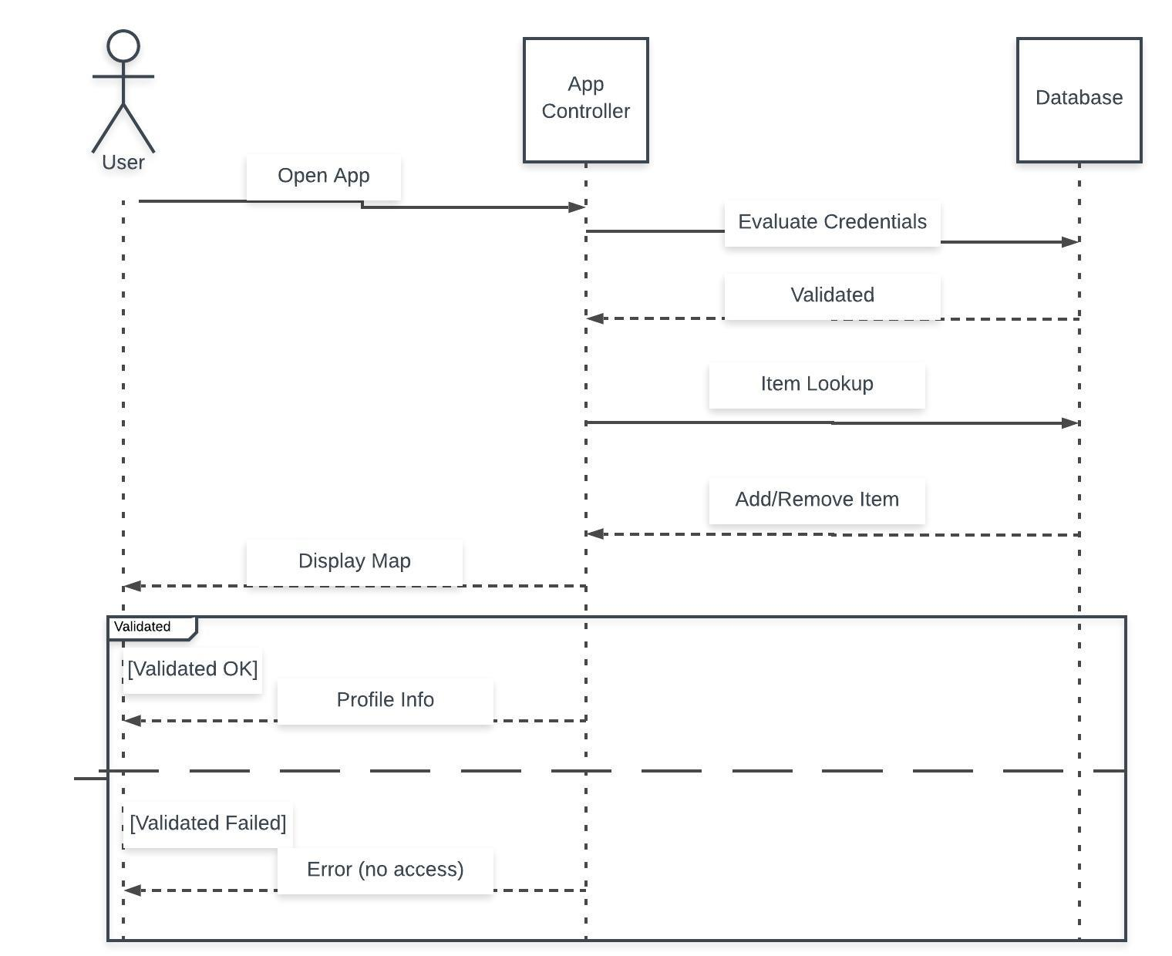

**G. Class diagram**

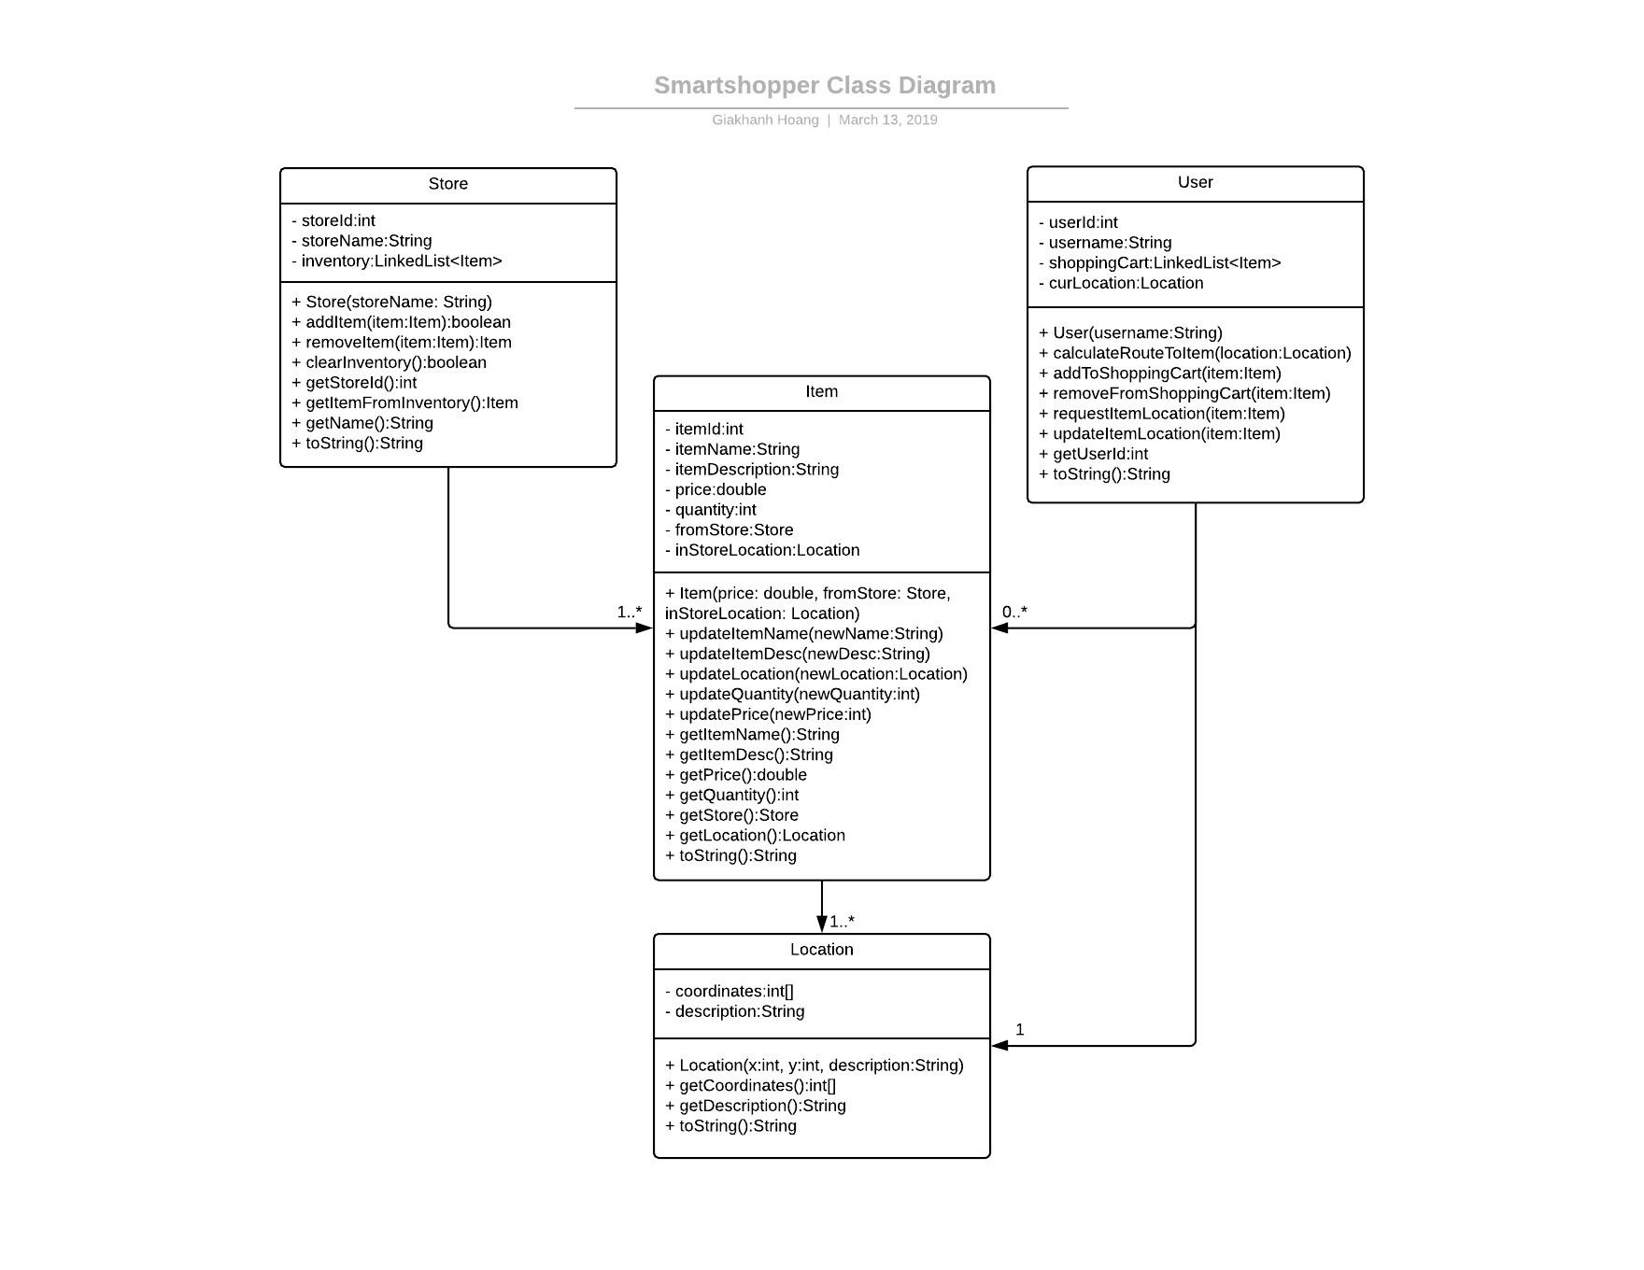

**H. Architectural Design**

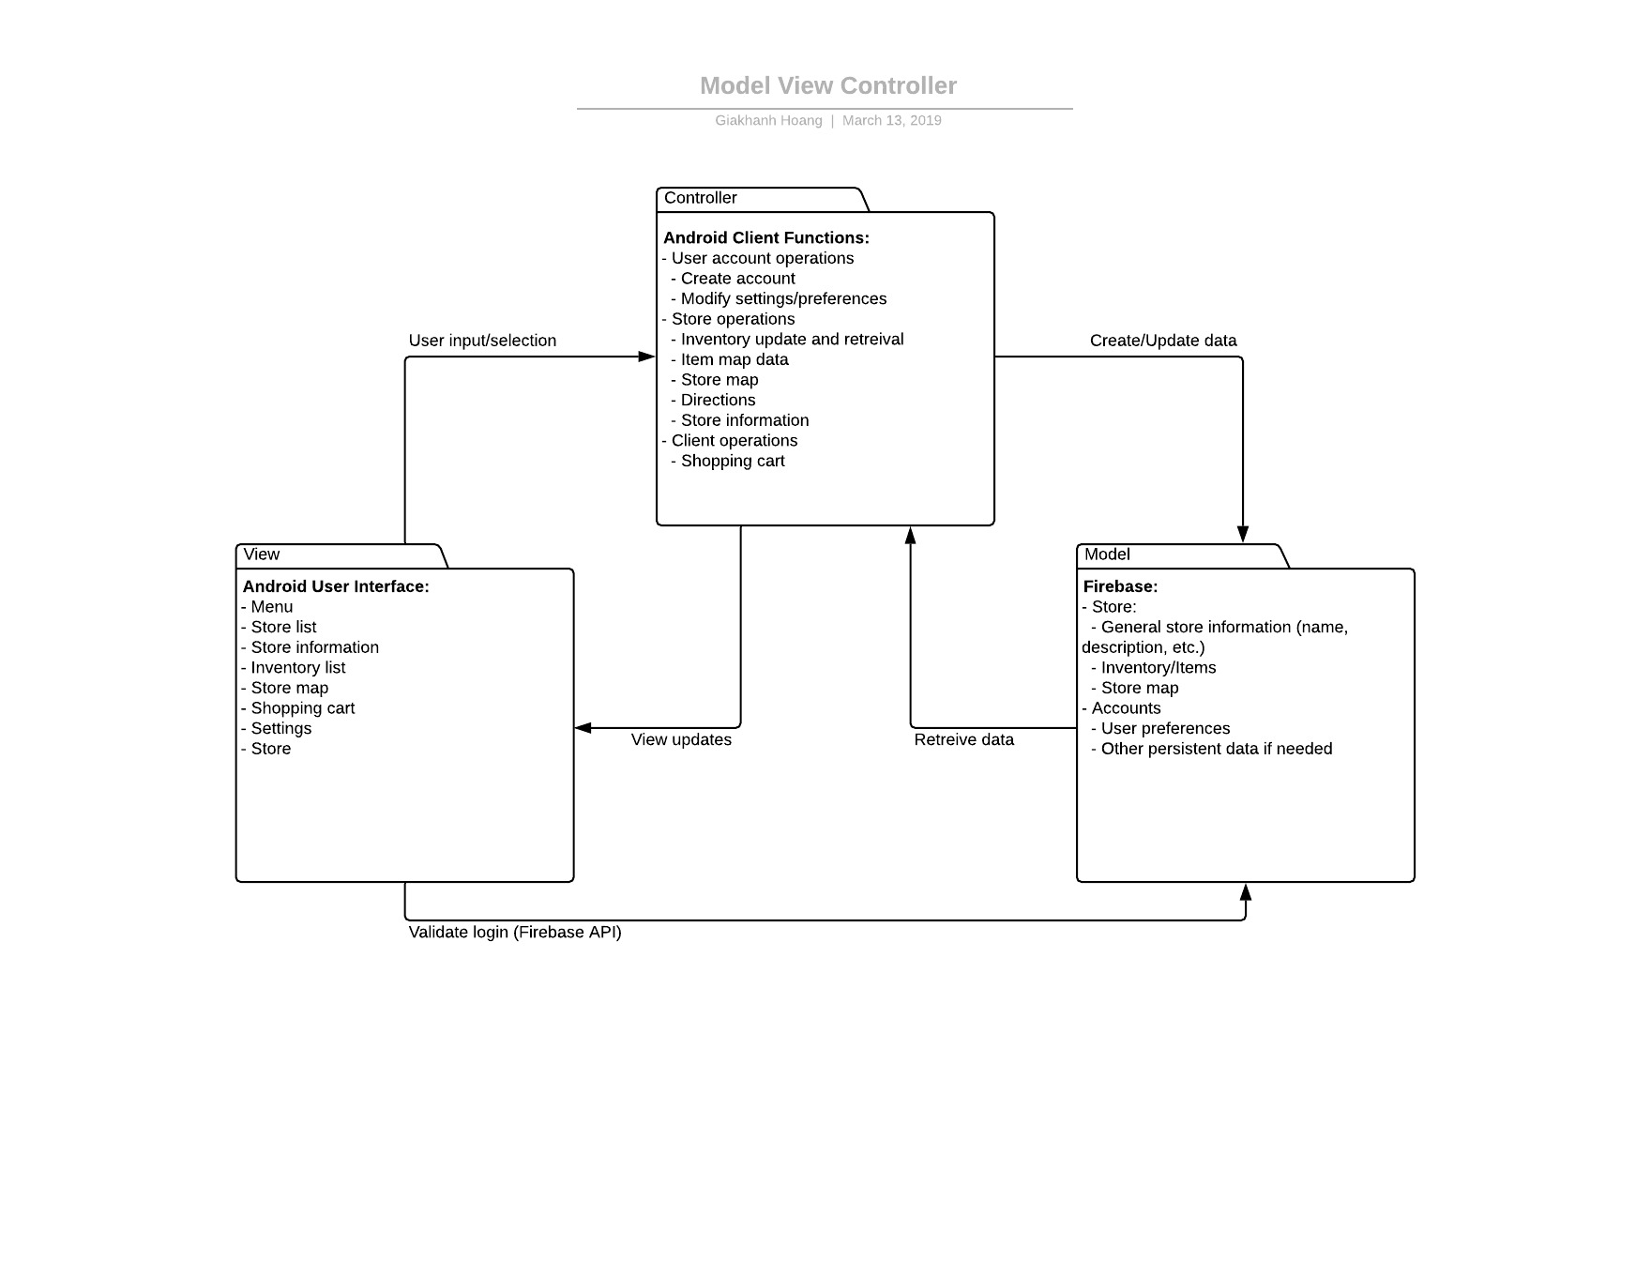

Our team believes the “Model View Controller” is best for our software needs since the Firebase database is the model while the Android app UI is the view and the backend part of the Android app, the client code, is the controller.

1. **Project Studies:**
   1. **Project Scheduling**

*See the Microsoft Project file attached in the zip file*

* 1. **Cost, Effort and Pricing Estimation**

**7 | Screens -** Menu, Store List, Store Information, Inventory List, Store Map, Shopping Cart, Settings and Store

**2 |** Data Tables - User and Store

**1 |** Report - Inventory List

**1 |** 3rd Generation Language – Java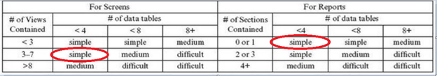

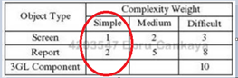

**Screen = 1 * 7 = 7**

**Report = 2 * 1 = 2**

**3GL = 1 * 10 = 10**

**OP = 19**

**NOP =** OP * (100 – *reuse*) / 100 = 19 * (100 – 50) / 100 = 19 * (.5) = 9.5

**Member Values:** Andres = 13, Anthony = 13, Giakhanh = 25, Kevin = 25, Palak = 7, Tien = 13

**PROD =** 16

**PM =** NOP / PROD = 9.5 / 16 = 0.594

* 1. **Estimated Cost of Hardware Products**
     1. Smart Phone (Android) - $700 [3]
  2. **Estimated Cost of Software Products**
     1. Firebase - $25/month (Flame subscription) [2]
  3. **Estimated Cost of Personnel**
     1. Lead Software Engineer - $100,000/yr [1]
     2. Database Administrator - $75,000 [1]
     3. Testing Engineer - $50,000/yr [1]
     4. QA Engineer - $45,000/yr [1]
     5. UX Designer - $43,000/yr [1]

1. **Test Plan:**
   1. We will use the JUnit test module that is integrated into Android Studio to test aspects of our app that are likely to be used and modified often.
   2. The test unit, *InventoryUnitTest*, provided in the zip file, within the android-app folder, tests various basic methods used in Item and Store object interactions, such as creating an item and adding it to the store’s inventory. The test cases provided involve valid fictional items, a default item, and a null item. The result of passing a null item should not be able to be added to the inventory, a default item should also not be allowed to be added to the inventory, and the valid fictional item should be accepted and added into the inventory.

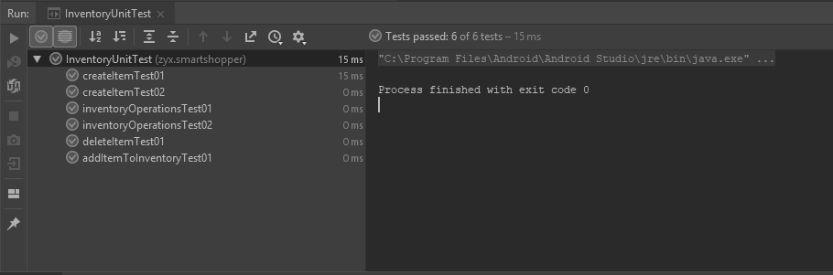

1. **Comparison with Similar Designs:** 
   1. The concept of using an app to navigate and search for grocery items is not a new idea. Another app, called Shops by aisle411, According to the product website, this app “find products carried at nearby stores for over 200,000 store locations [and] locate and map products down to the aisle and section inside over 13,000 stores with searchable indoor maps.” [4] When a user inputs a product name, it will search for the item in its database and then outputs its location on the map, just like our app does. For example, if one were to search for “bananas”, it would mark the location of bananas on a map of the store, in the produce section. How, then, is our app different from this working product? The main difference is that SmartShopper is designed for crowdsourcing, which means that customers can update the database to reflect changes in the location of products. For instance, a convenience store decides to move the location of Doritos from the snacks aisle to the front of the store, near the cash registers. Shops by aisle411 will not be able to easily account for this change, as the store has to send a request for the data to be changed, which might take days, in order for this change to be accounted for in the system. Meanwhile, with SmartShopper, changes can be accounted for quickly because, as shoppers start noticing this change, they can report this change to our app, and after a quick review, it can be accounted for in the system. Waze was the inspiration for this feature, because a major reason why mobile users used Waze instead of other mapping apps was because of the crowdsourced reports. This way, for example, the users of the app can find the best way through traffic in real time, since traffic is constantly being reported by Waze users driving on the roads. Waze as a navigation app is not just making an impact in the United States; according to Digital Initiative at Harvard Business School, “It relies on user data to monitor and relay traffic information for its maps in +185 countries around the globe.” [5] Thus, our team saw real potential in incorporating this very useful feature into our app.
2. **Conclusion:**
   1. Our work on the development of SmartShopper showed several hurdles to overcome. The first of them was deciding on the project idea and name, but to that end, we all settled on a very enticing solution that many others appreciated as well. Second was delegating specific roles for each member and keeping to our Scrum sprint schedules. This proved to be quite difficult with all team members having other class assignments that proved to be very time consuming. As a result, our designated roles were shared among others in order to finish weekly tasks on time. Lastly, due to what was said before, our original plan to develop a fully working prototype was unfortunately never met. All in all, our team was successful in communicating and designing the necessary details for the future production of our very unique and much sought after application.

**References:**

[1] “Search Job Salaries,” *PayScale*, 01-Jan-2019. [Online]. Available: https://www.payscale.com/research/US/Job. [Accessed: 17-Apr-2019].

[2] “Pricing Plans,” *Firebase*. [Online]. Available: https://firebase.google.com/pricing/. [Accessed: 16-Apr-2019].

[3] M. Spoonauer, “Galaxy S9 and S9 Review,” *Tom's Guide*, 25-Feb-2019. [Online]. Available: https://www.tomsguide.com/us/galaxy-s9-s9-plus,review-5198.html. [Accessed: 18-Apr-2019].

[4] *Shops by Aisle411*. [Online]. Available: http://aisle411.com/shops/. [Accessed: 19-Apr-2019].

[5] K. Müller, “How crowdsourcing is changing the Waze we drive,” *Technology and Operations Management*. [Online]. Available: https://rctom.hbs.org/submission/how-crowdsourcing-is-changing-the-waze-we-drive/. [Accessed: 19-Apr-2019].